Name : Aashesh kumar

Roll #: k173901

Web programing assignment one

url from my p.c :

file:///C:/Users/Aashesh%20kumar/AppData/Local/Temp/Temp1_Aashish.zip/Aashish/index.html

Report of assignment

How to run it

Use xamp or visual studio load file to c drive and simply open from directory by any internet browsers

Validation

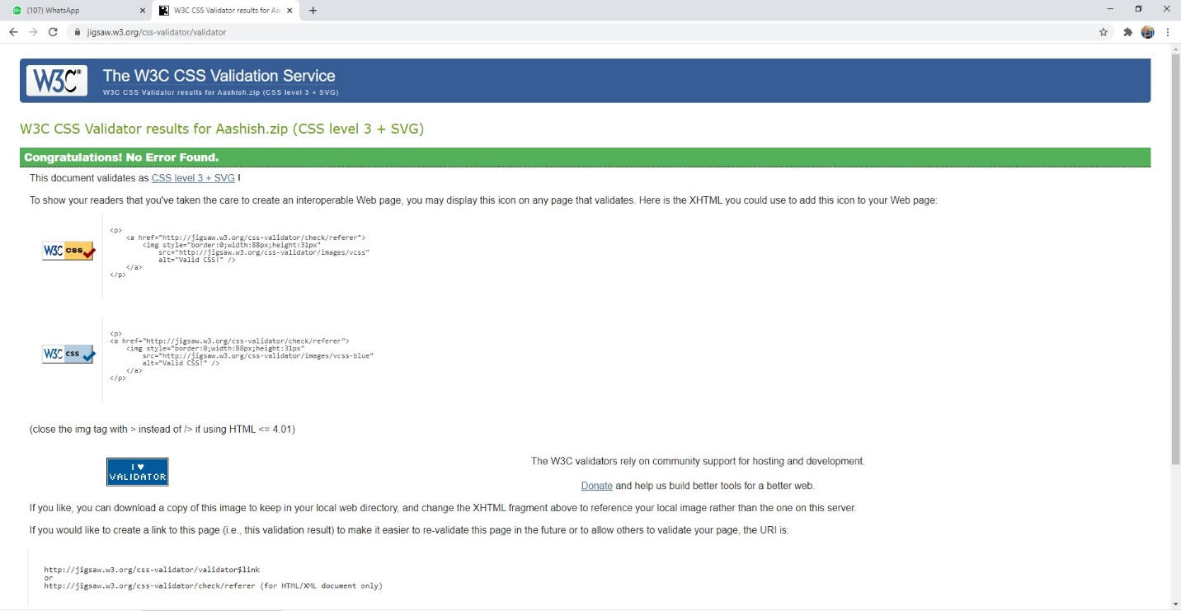

The interface look up home page

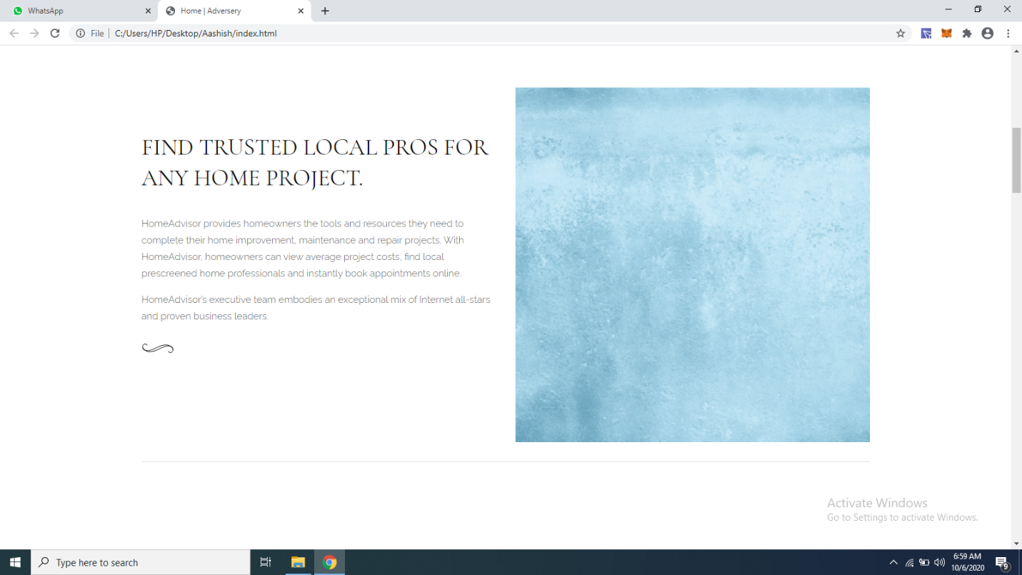

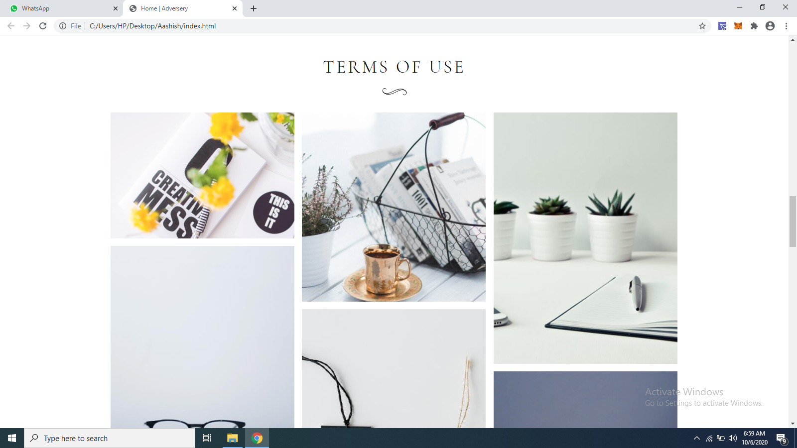





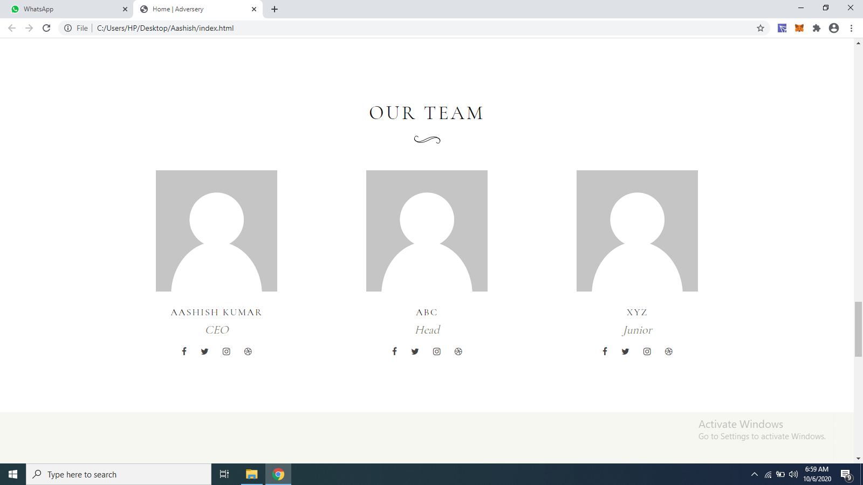

Contact page

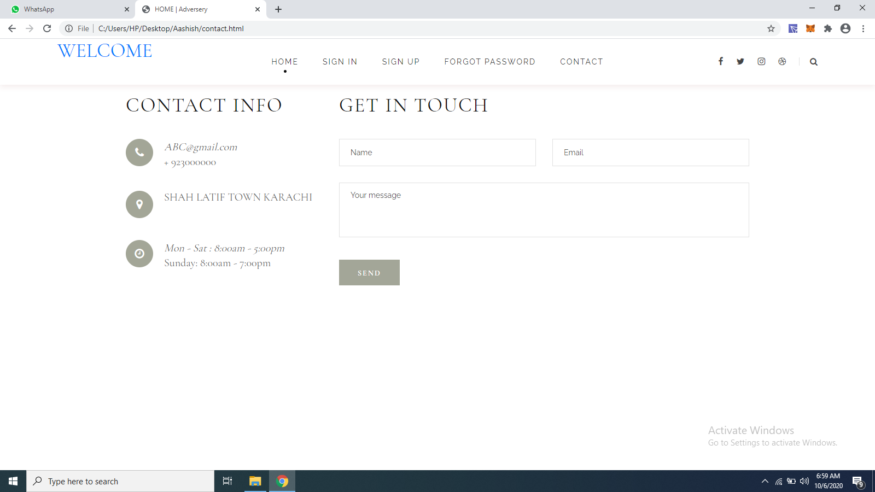

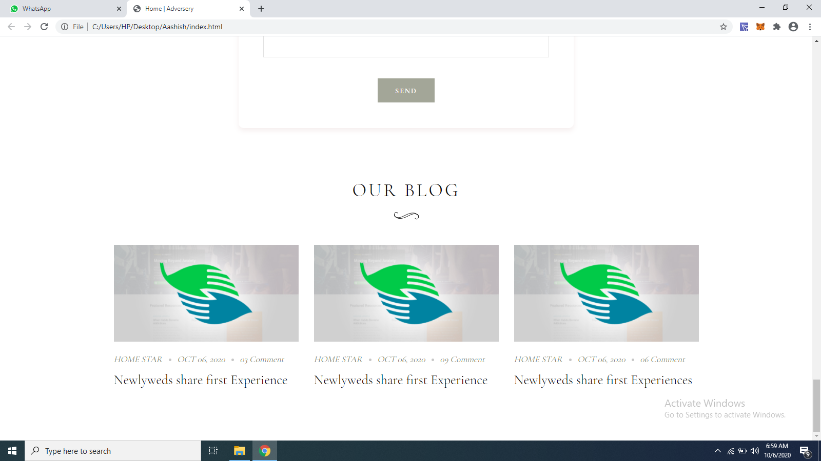

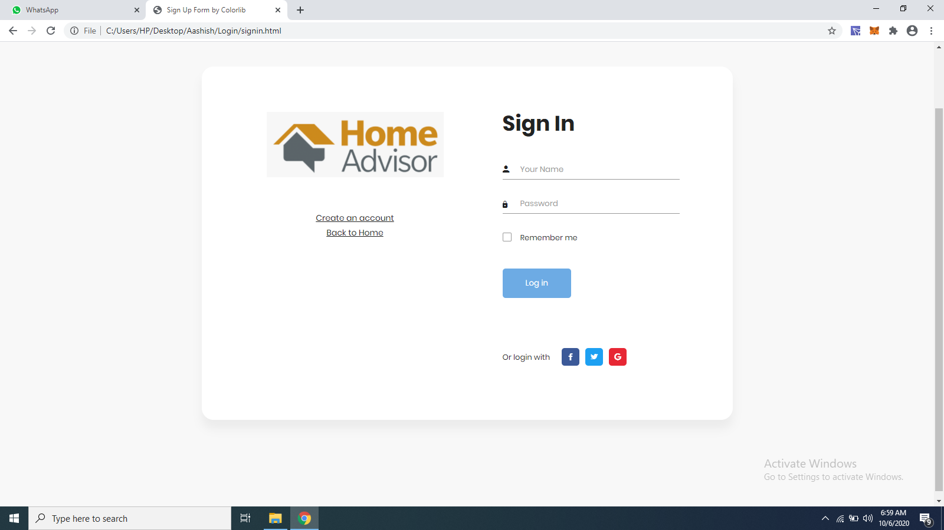Sign in UI

SIGN UP UI

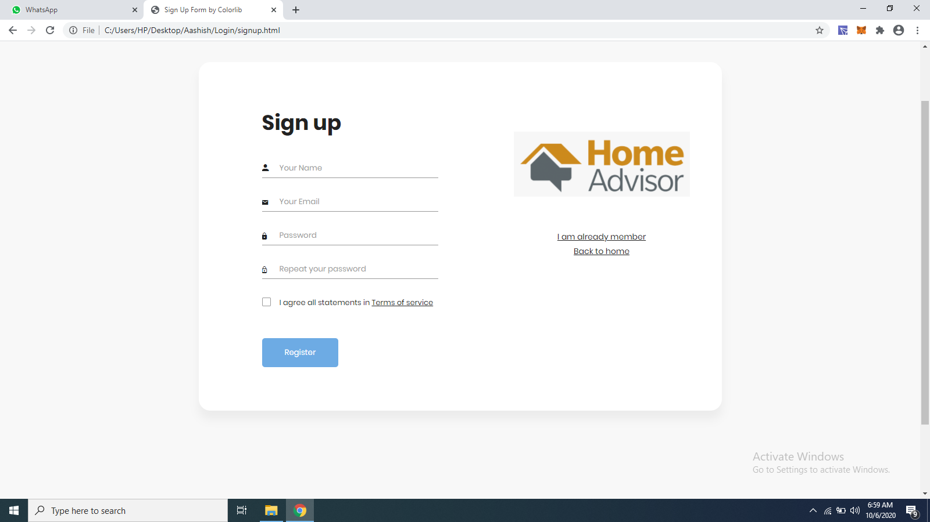

Forgot password UI

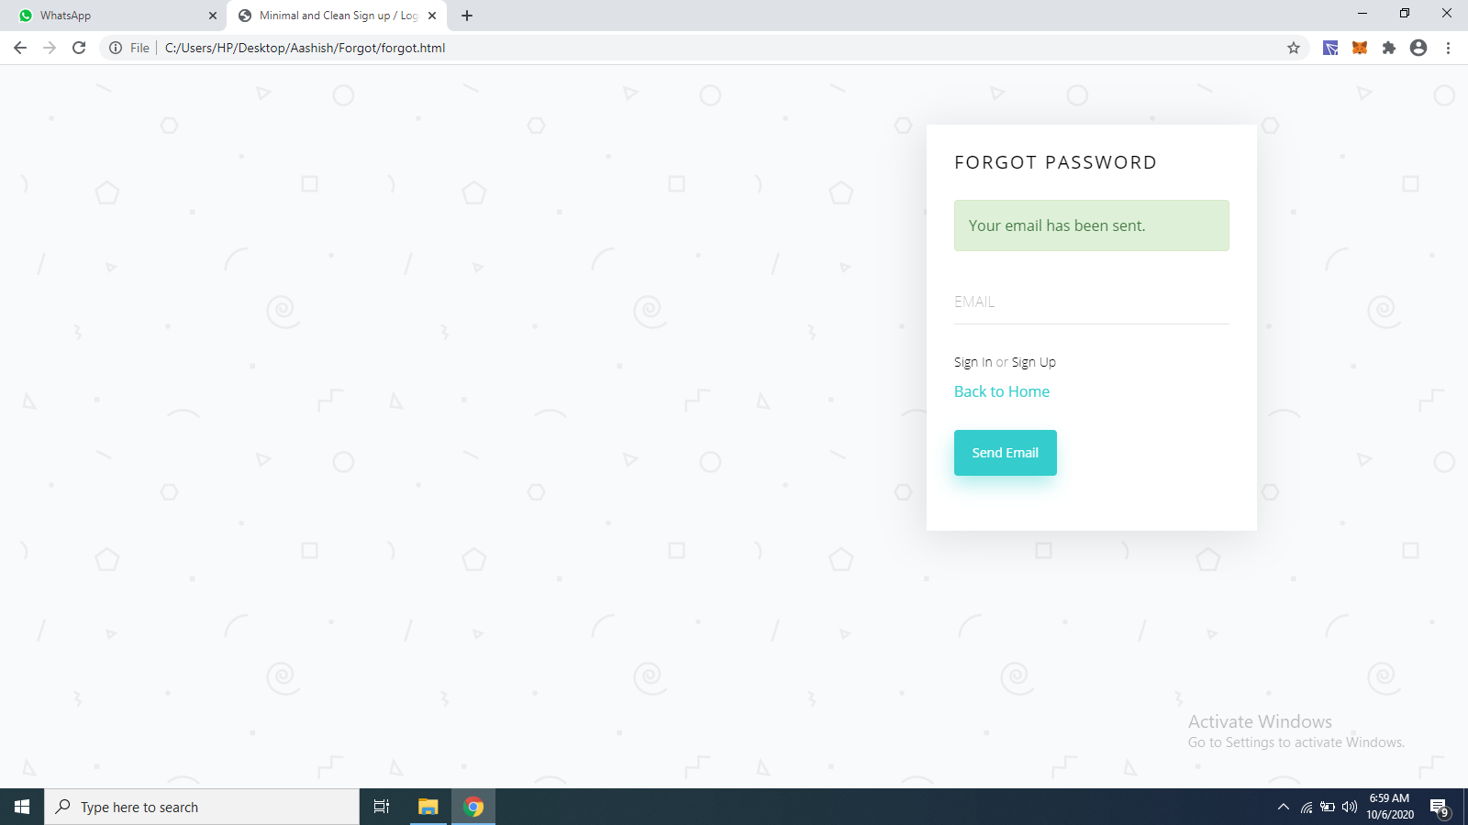

Thankyou